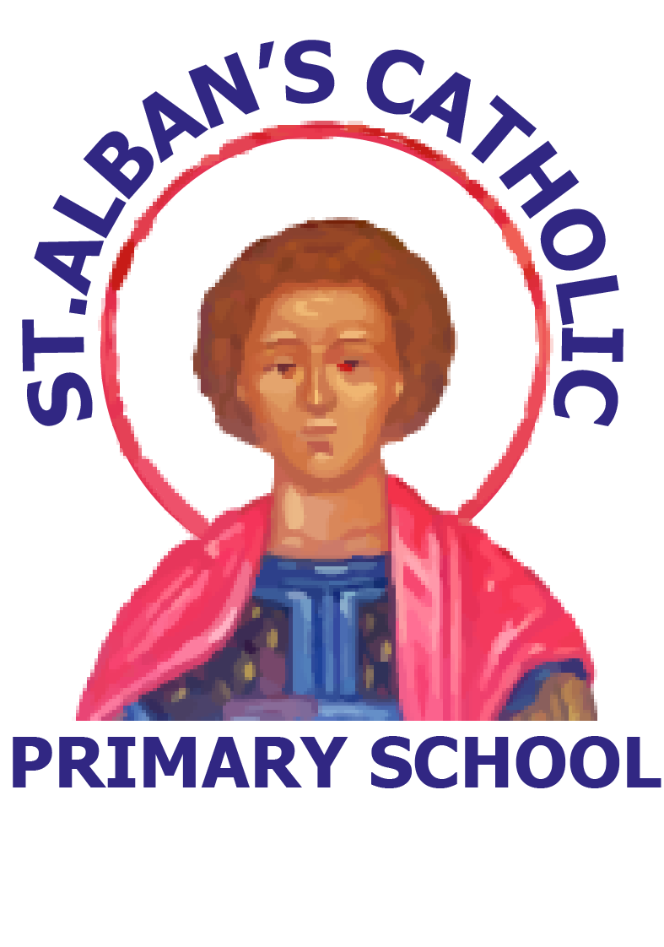
St. Alban’s Catholic Primary School
KS2 HEP Science Overview of topics for 2023 - 2024

 | A1 | A2 | L1 | L2 | T1 | T2
Y3 | Plants | The Science of Rocks | The Science of Light | Animals including Humans | Forces and Magnets | The Bee Project
Y4 | States of Matter | Animals including Humans | The Science of Sound | Living things and their Habitats | Electricity | The History of Science
Y5 | Properties and changes of Materials | Animals including Humans | Forces | Living things and their Habitats | Earth and Space | The Scientific Method
Y6 | Animals including Humans | The Science of Light | Electricity | Evolution and Inheritance | Living things and their Habitats | TBC by HEP

Biology | Physics | Chemistry

